Edinburgh College
Design Document
MURF MAX
Jay Reid ec1943892

Contents
Wireframes 2
Style Guide 4
Storyboard 6
Navigation System 7
Design behaviour and interactions 9
Non-Functional Prototype 10

Wireframes

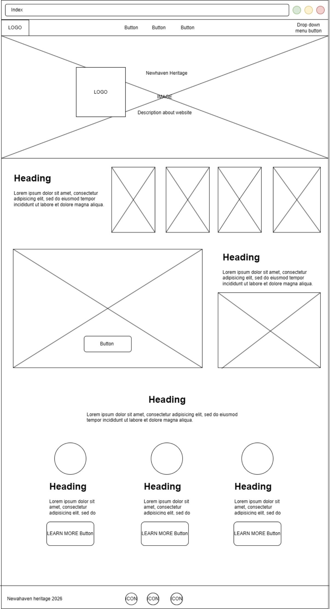
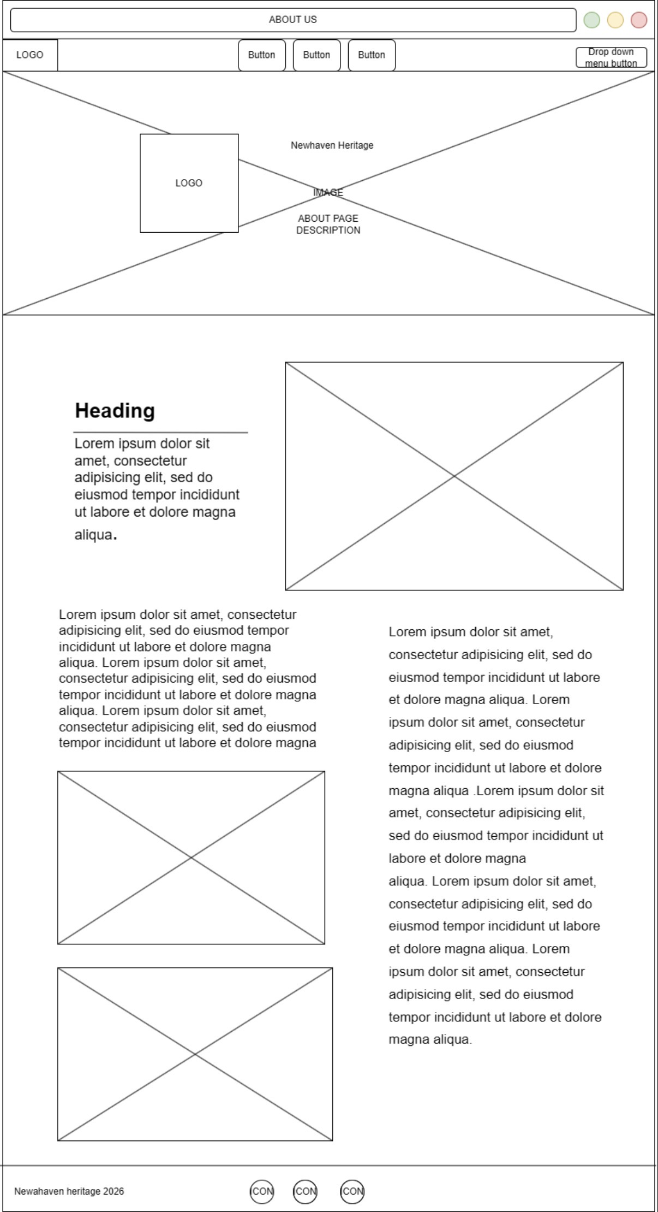

Style Guide

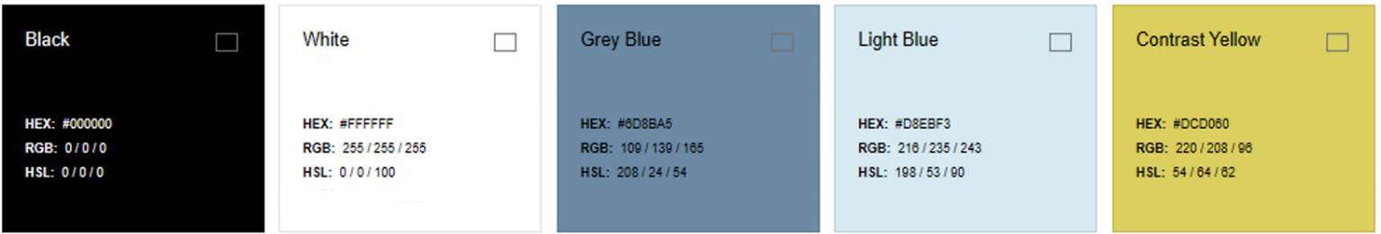
Colours:

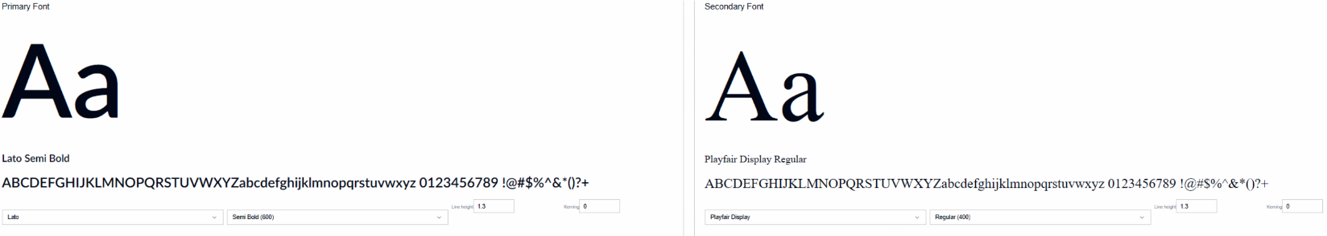
Typography:

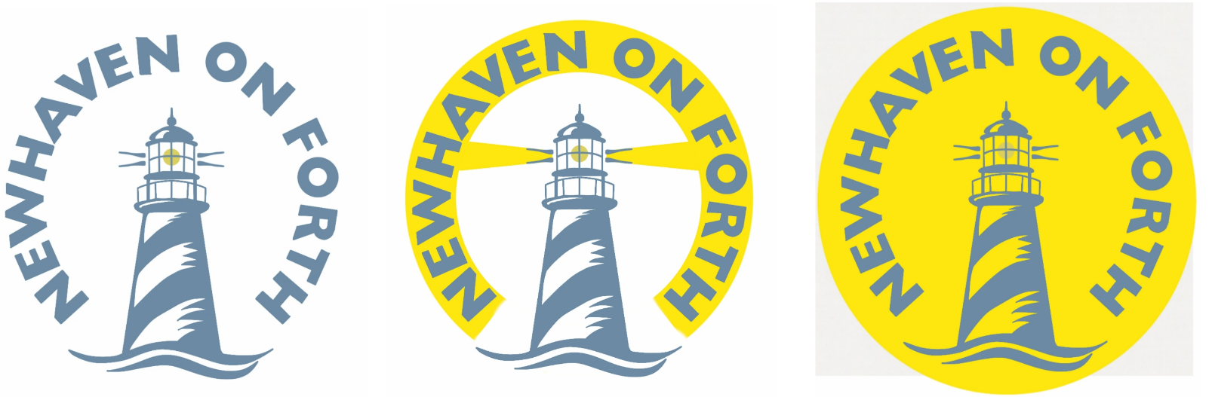
Primary Logo & Variations:

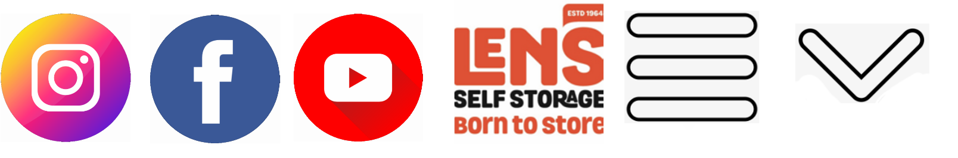

Buttons & Interactives:

Storyboard

Navigation System
We will create a navigation bar that will be present on every page that features links to all 7 pages, including:
- Home Page
- Our Vision Page
- About Us Page (policies)
- Current Events Page:
Cruise ship arrivals,
Newhaven Pageant,
Phoenix project,
Scan Saturdays,
Past events,
The bow-tow newsletter)
- Groups Page (Community choir,
Gardening group,
Newhaven community history group)
- Links Page
- Contact Us Page
We will be condensing multiple pages of the same category into one master page with a feature to switch the currently shown content, these pages include:

- Cruise ship arrivals Page into Current Events Page
- Newhaven Pageant Page into Current Events Page
- Pheonix project Page into Current Events Page
- Scan Saturdays Page into Current Events Page
- Past events Page into Current Events Page
- The bow-tow newsletter Page into Current Events Page
- Community choir Page into Groups Page
- Gardening group Page into Groups Page
- Newhaven community history group Page into Groups Page
We will be removing certain pages that either lack content or are irrelevant today, these pages include:
- Reports Page for lack of function and relevance.
- Shop Page since the shop has not been built.
- A Poverty of Vision Page since the content is now old and irrelevant.
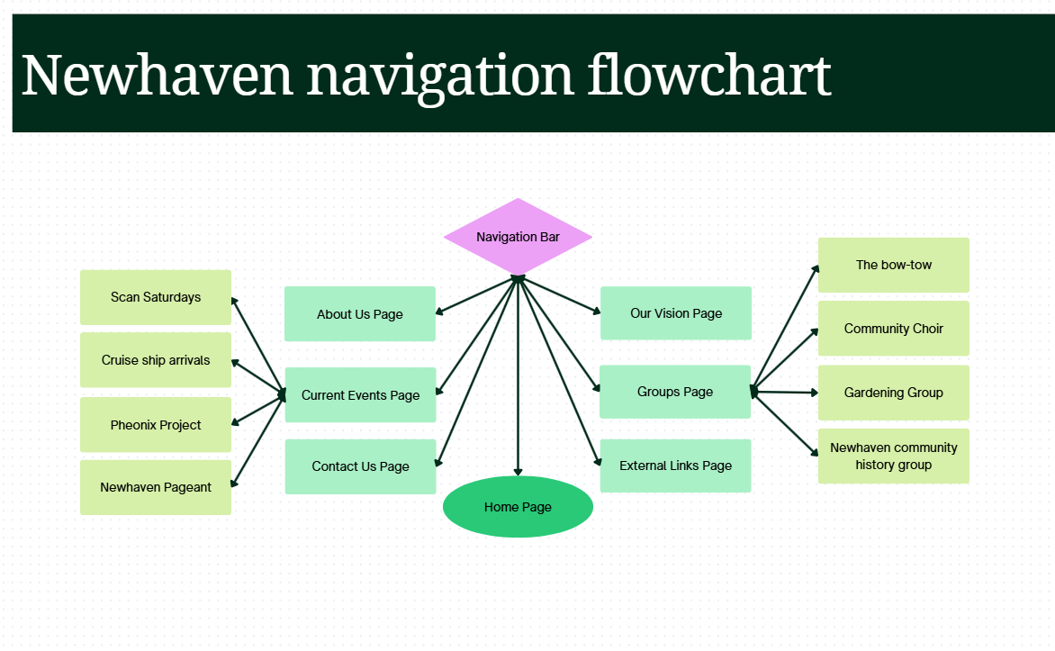
Navigation Flowchart:
Flowchart features pages in green and additional page content in lime.

Design behaviour and interactions

Hover effects:
All buttons grow larger on hover along with increased border radius (Mobile excluded).

Image carousel:
Carousel with stretch effects to make it appear 3d and modern. All carousel elements grow larger on hover and link to pages or in-page content. Mouse hold click to drag along with arrow buttons and automatic transitions every 5 seconds. Mouse click to access elements content or link to respective page.

Page load effects:
Slide transition on hero section of each page making the page title and hero section image visible.

Button-Press interactions:
The read more buttons will make an element visible with a sliding down transition originating from the button and taking up a large width.
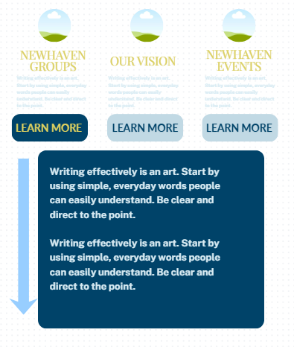
The newly visible element will push down lower elements to properly take up space.

Non-Functional Prototype

